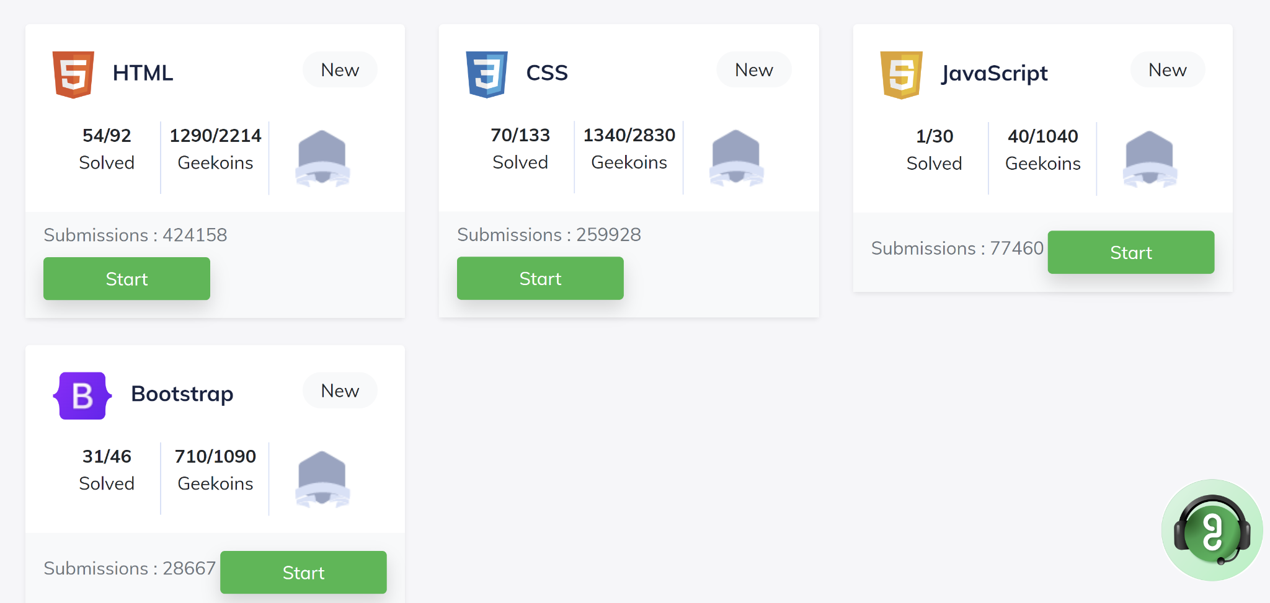

HTML-10

CSS-20

Bootstrap-20

Total -50